Putni no papīra

[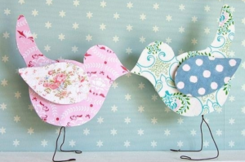](http://www.iz-bumagi-svoimi-rukami.ru/wp-content/uploads/2016/07/Ptitsy-iz-bumagi-svoimi-rukami-74.png)

[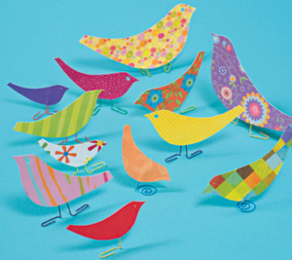](http://www.iz-bumagi-svoimi-rukami.ru/wp-content/uploads/2016/07/Ptitsy-iz-bumagi-svoimi-rukami-44.png)

Bezdelīga

[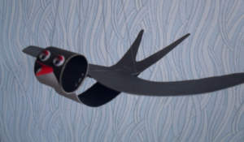](http://www.iz-bumagi-svoimi-rukami.ru/wp-content/uploads/2016/07/Ptitsy-iz-bumagi-svoimi-rukami-39.png)

[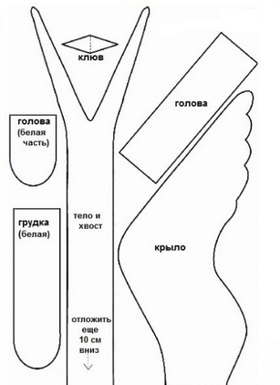](http://www.iz-bumagi-svoimi-rukami.ru/wp-content/uploads/2016/07/Ptitsy-iz-bumagi-svoimi-rukami-40.png)

[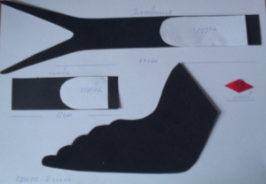](http://www.iz-bumagi-svoimi-rukami.ru/wp-content/uploads/2016/07/Ptitsy-iz-bumagi-svoimi-rukami-35.png)

[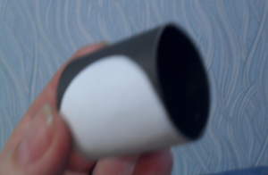](http://www.iz-bumagi-svoimi-rukami.ru/wp-content/uploads/2016/07/Ptitsy-iz-bumagi-svoimi-rukami-36.png)

[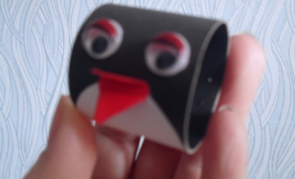](http://www.iz-bumagi-svoimi-rukami.ru/wp-content/uploads/2016/07/Ptitsy-iz-bumagi-svoimi-rukami-37.png)

[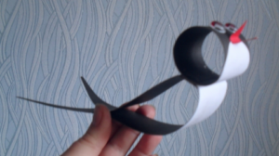](http://www.iz-bumagi-svoimi-rukami.ru/wp-content/uploads/2016/07/Ptitsy-iz-bumagi-svoimi-rukami-38.png)

[](http://www.iz-bumagi-svoimi-rukami.ru/wp-content/uploads/2016/07/Ptitsy-iz-bumagi-svoimi-rukami-39.png)

[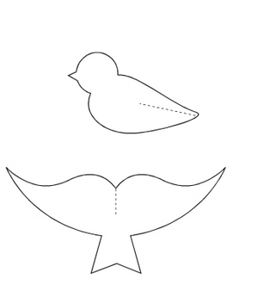](http://www.iz-bumagi-svoimi-rukami.ru/wp-content/uploads/2016/07/Ptitsy-iz-bumagi-svoimi-rukami-34.png)

Putns no apļiem

[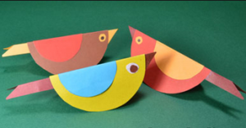](http://www.iz-bumagi-svoimi-rukami.ru/wp-content/uploads/2016/07/Ptitsy-iz-bumagi-svoimi-rukami-41.png)

[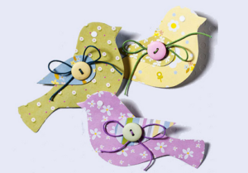](http://www.iz-bumagi-svoimi-rukami.ru/wp-content/uploads/2016/07/Ptitsy-iz-bumagi-svoimi-rukami-48.png)

[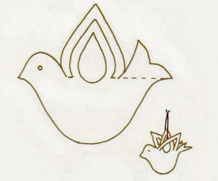](http://www.iz-bumagi-svoimi-rukami.ru/wp-content/uploads/2016/07/Ptitsy-iz-bumagi-svoimi-rukami-42.png)

Gulbis

[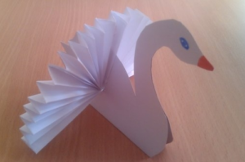](http://www.iz-bumagi-svoimi-rukami.ru/wp-content/uploads/2016/07/Ptitsy-iz-bumagi-svoimi-rukami-50.png)

[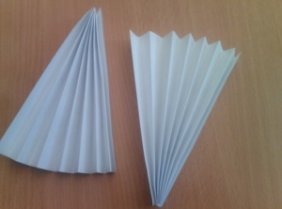](http://www.iz-bumagi-svoimi-rukami.ru/wp-content/uploads/2016/07/Ptitsy-iz-bumagi-svoimi-rukami-51.png)

[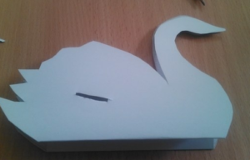](http://www.iz-bumagi-svoimi-rukami.ru/wp-content/uploads/2016/07/Ptitsy-iz-bumagi-svoimi-rukami-52.png)[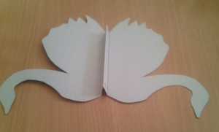](http://www.iz-bumagi-svoimi-rukami.ru/wp-content/uploads/2016/07/Ptitsy-iz-bumagi-svoimi-rukami-53.png)[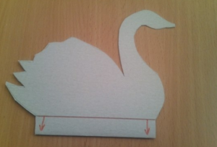](http://www.iz-bumagi-svoimi-rukami.ru/wp-content/uploads/2016/07/Ptitsy-iz-bumagi-svoimi-rukami-54.png)[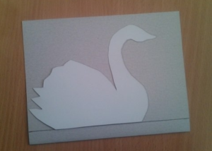](http://www.iz-bumagi-svoimi-rukami.ru/wp-content/uploads/2016/07/Ptitsy-iz-bumagi-svoimi-rukami-55.png)[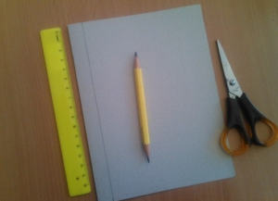](http://www.iz-bumagi-svoimi-rukami.ru/wp-content/uploads/2016/07/Ptitsy-iz-bumagi-svoimi-rukami-56.png)[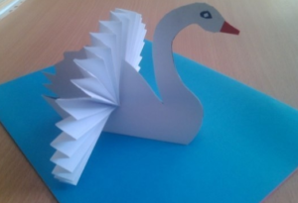](http://www.iz-bumagi-svoimi-rukami.ru/wp-content/uploads/2016/07/Ptitsy-iz-bumagi-svoimi-rukami-57.png) [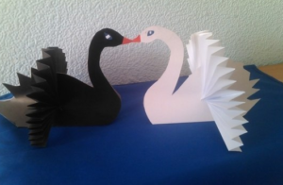](http://www.iz-bumagi-svoimi-rukami.ru/wp-content/uploads/2016/07/Ptitsy-iz-bumagi-svoimi-rukami-58.png)[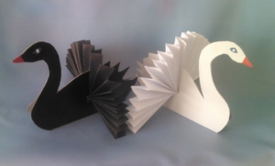](http://www.iz-bumagi-svoimi-rukami.ru/wp-content/uploads/2016/07/Ptitsy-iz-bumagi-svoimi-rukami-49.png)

[](http://www.iz-bumagi-svoimi-rukami.ru/wp-content/uploads/2016/07/Ptitsy-iz-bumagi-svoimi-rukami-71.png)

[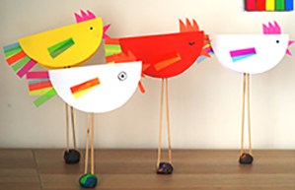](http://www.iz-bumagi-svoimi-rukami.ru/wp-content/uploads/2016/07/Ptitsy-iz-bumagi-svoimi-rukami-59.png)

[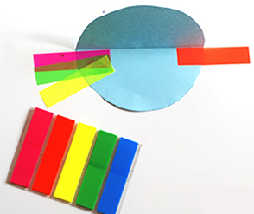](http://www.iz-bumagi-svoimi-rukami.ru/wp-content/uploads/2016/07/Ptitsy-iz-bumagi-svoimi-rukami-60.png)

[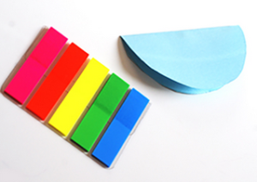](http://www.iz-bumagi-svoimi-rukami.ru/wp-content/uploads/2016/07/Ptitsy-iz-bumagi-svoimi-rukami-61.png)

[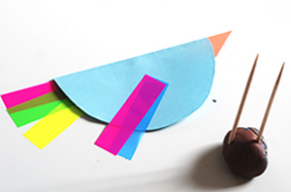](http://www.iz-bumagi-svoimi-rukami.ru/wp-content/uploads/2016/07/Ptitsy-iz-bumagi-svoimi-rukami-62.png)

[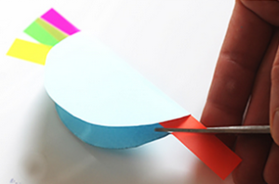](http://www.iz-bumagi-svoimi-rukami.ru/wp-content/uploads/2016/07/Ptitsy-iz-bumagi-svoimi-rukami-63.png)

[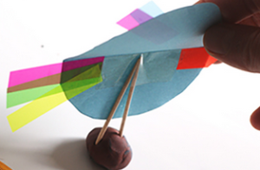](http://www.iz-bumagi-svoimi-rukami.ru/wp-content/uploads/2016/07/Ptitsy-iz-bumagi-svoimi-rukami-64.png)

[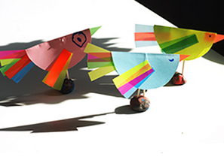](http://www.iz-bumagi-svoimi-rukami.ru/wp-content/uploads/2016/07/Ptitsy-iz-bumagi-svoimi-rukami-65.png)

[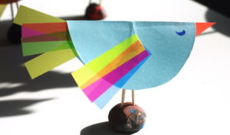](http://www.iz-bumagi-svoimi-rukami.ru/wp-content/uploads/2016/07/Ptitsy-iz-bumagi-svoimi-rukami-67.png)

[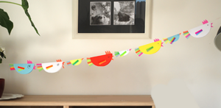](http://www.iz-bumagi-svoimi-rukami.ru/wp-content/uploads/2016/07/Ptitsy-iz-bumagi-svoimi-rukami-66.png)

[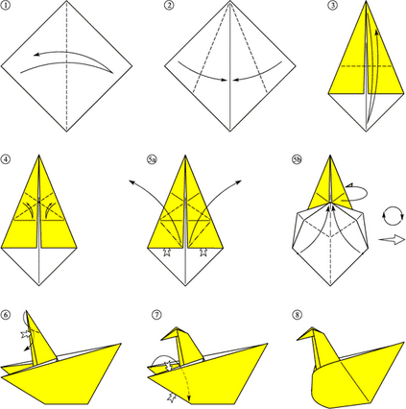](http://www.iz-bumagi-svoimi-rukami.ru/wp-content/uploads/2016/07/Ptitsy-iz-bumagi-svoimi-rukami-68.png)

[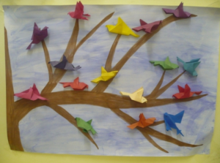](http://www.iz-bumagi-svoimi-rukami.ru/wp-content/uploads/2016/07/Ptitsy-iz-bumagi-svoimi-rukami-46.png)

[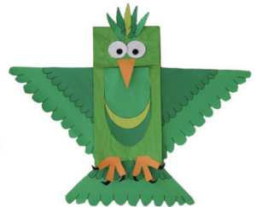](http://www.iz-bumagi-svoimi-rukami.ru/wp-content/uploads/2016/07/Ptitsy-iz-bumagi-svoimi-rukami-69.png)

[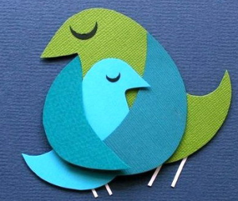](http://www.iz-bumagi-svoimi-rukami.ru/wp-content/uploads/2016/07/Ptitsy-iz-bumagi-svoimi-rukami-70.png)

[](http://www.iz-bumagi-svoimi-rukami.ru/wp-content/uploads/2016/07/Ptitsy-iz-bumagi-svoimi-rukami-73.png)

[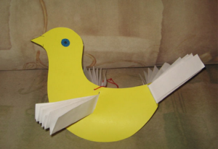](http://www.iz-bumagi-svoimi-rukami.ru/wp-content/uploads/2016/07/Ptitsy-iz-bumagi-svoimi-rukami-45.png)

[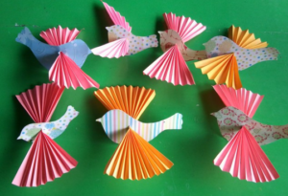](http://www.iz-bumagi-svoimi-rukami.ru/wp-content/uploads/2016/07/Ptitsy-iz-bumagi-svoimi-rukami-43.png)

[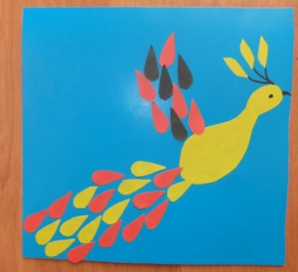](http://www.iz-bumagi-svoimi-rukami.ru/wp-content/uploads/2016/07/Ptitsy-iz-bumagi-svoimi-rukami-75.png)

[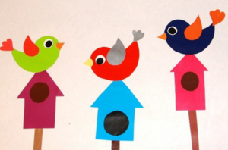](http://www.iz-bumagi-svoimi-rukami.ru/wp-content/uploads/2016/07/Ptitsy-iz-bumagi-svoimi-rukami-76.png)

[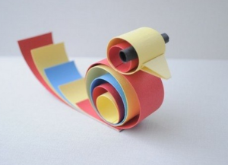](http://www.iz-bumagi-svoimi-rukami.ru/wp-content/uploads/2016/07/Ptitsy-iz-bumagi-svoimi-rukami-77.png)

[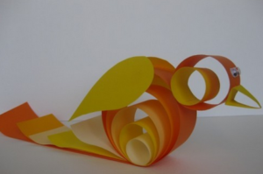](http://www.iz-bumagi-svoimi-rukami.ru/wp-content/uploads/2016/07/Ptitsy-iz-bumagi-svoimi-rukami-72.png)

[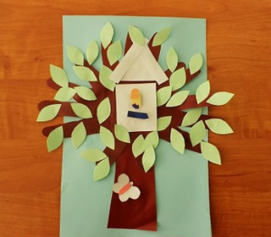](http://www.iz-bumagi-svoimi-rukami.ru/wp-content/uploads/2016/07/Ptitsy-iz-bumagi-svoimi-rukami-78.png)

[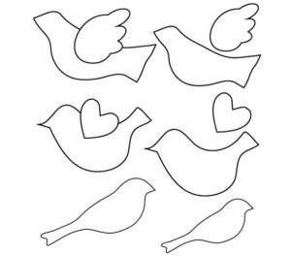](http://www.iz-bumagi-svoimi-rukami.ru/wp-content/uploads/2016/07/Ptitsy-iz-bumagi-svoimi-rukami-32.png)

[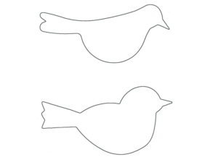](http://www.iz-bumagi-svoimi-rukami.ru/wp-content/uploads/2016/07/Ptitsy-iz-bumagi-svoimi-rukami-33.png)